

**COMP1108/COMP1181 – Project**

**Final Year Project Proposal**

**Title : Movie Rental Website**

**Supervisor:** Kelvin

**Student Name:** Lim Wan Choon

**Student ID:** **001045196**

**Student Email:** limwc1998@gmail.com

Contents

1. Current Situation 3

1.1 Changes to Proposal 3

1.2 Research 4

2. Key Work during the Next Period 4

Appendix A 5

**Introduction** 5

**A1. Literature Review on the Key Phrases** 5

**1.** **Watch Movie Online** 5

**2.** **Movie Renting** 6

**3.** **Online Movie Store** 7

**4.** **Genre** 8

**5.** **Online Marketing** 9

**A2. Literature Review on the 3 similar system** 10

**1.** **Netflix** 10

**2.** **Amazon Prime Video** 12

**3.** **Google Play Movies** 14

Conclusion 16

Reference 17

Appendix B – Gantt Chart 18

# Current Situation

# Changes to Proposal

1. Amendments have been made onto Objectives area due to supervisor request.

**Objectives**

1. To provide simple registration process for customer

**Activities**

* To conduct findings on short registration

**Deliverables**

* To develop a simple and short registration for customer to sign up

1. To provide admins controls to organize movies

**Activities**

* To conduct finding on data tables

**Deliverables**

* To develop a data table that consist of CRUD functions

1. To provide users with selection of several membership packages

**Activities**

* To conduct finding on benefits given from membership packages

**Deliverables**

* To develop several membership packages with benefits for users

1. To provide a secure payment gateway for the user

**Activities**

* To conduct findings on payment method

**Deliverables**

* To develop a payment method for the user

1. Removes notification management from functional requirements
2. Added generating report into Membership Package for admins
3. Added sales report into Payment Management for admins
4. Moves notification for new products into movies management
5. Moves rental made by the user into rental management
6. Changes on key phrases

# Research

Research has been conducted on 5 key phrases and 3 similar systems. The method being used is fact finding from online sources.

# Key Work during the Next Period

Develop ERD, DFD, UML and Use Case Diagram.

# Appendix A

## **Introduction**

The purpose of this literature review is to conduct findings and obtain necessary knowledge to develop a movie rental website. To conduct this literature review, fact finding on online sources will be used and 3 similar websites relevant to movie rental website will be chosen.

## **A1. Literature Review on the Key Phrases**

### **Watch Movie Online**

Watching movies online is a popular form of entertainment for who prefer to remain indoors during their free time. Watching movies not only helps relax the person mind, they also get to experience high levels of concentration which is good for their brain and relaxing on a couch to watch movies for hours also heals their body of a long tiresome day or week (LL Brothers Entertainment Geeks, n.d.).

Today, we can watch movies on several platforms such as Facebook, YouTube, Netflix and more. Television and DVD players are used to be common when watch online movie were more expensive and dangerous than it used to be but now most of the legal website that is providing users to watch movie online are free and under legal company which has better security to protect their users (LL Brothers Entertainment Geeks, n.d.).

There are several advantages of watching movie online. First, most of watch movie online platform offers varieties of movies from different genres. This is good compared to other online platform that offers limited number of movies to watch because the limitation applied will cause users sometime unable to find what movie they are looking for (LL Brothers Entertainment Geeks, n.d.).

Online movie platform also offer high quality movies on their sites to make sure their users has an enjoyable viewing experiences. This is better compared to DVDs because DVDs used to have a limited specific resolutions that is low (LL Brothers Entertainment Geeks, n.d.).

Other than that, online movie platform offers flexibility to their users which they are able to watch movies anywhere anytime they want. The only thing they need is a mobile devices and a stable connection to their movie sites (LL Brothers Entertainment Geeks, n.d.).

### **Movie Renting**

Movie renting works differently on different platforms. In this case, movie renting on Android platform will be used as an example. Movie Renting on Android platform has 2 time constraint which is

* How much time the user have to start the movie from the time they rent
* How much time the user have to finish watching the movie from time they start it

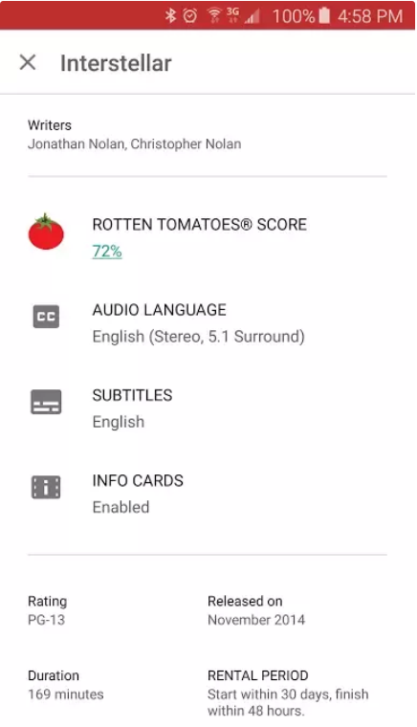

**Figure 1.1** (Ho, 2015)

From **Figure 1.1**, there is an information about Rental Period. The movie rented in **Figure 1.1** has 30 days for the user to start watching the movie before it expired from their list. When they start watching the movie, the will have another 48 hours that they are able to watch the movie again and again until the movie is expired from their list (Ho, 2015).

### **Online Movie Store**

Back in 80s where Blockbuster is still a movie store that sells and rents out movies to their customer before they ceased their operation globally in 2013 due to Netflix offers online streaming for their users that Blockbuster is not capable for.

Online movie store offers simple steps for their users to register and grant access to the website. The movies usually will be categorized into huge variety of genres for the users to look upon and use online payment method to rent the movie for a certain of period which enable the users to shop anywhere and anytime without the needs to walk into a physical store and buy one movie that will be leave in the dust after they have finished the movies several times (Discovery Design, n.d.).

With online movie store, their users usually will receives notifications about new arrivals or promotions, they don’t have to walk in to the physical store and keep asking when new products will be arrived or new promotions that they will be doing from when to when.

Most online movie store will offers certain membership packages to their users whether they want to enjoy certain benefits or not. The benefits usually contains of screen that can be streamed at the same time, quality of movie, remove certain limitations such as free movies that can be watched per day and more.

### **Genre**

Genre is used to categorize movies because this makes it easier for viewer to search for what they have in mind. Genre consists of four elements such as characters, story, plot and setting which are used to categorize movies into different category genre (Miline Library, n.d.).

Some common genres such as comedy will not be having a sub-genre comedy because sub-genre is based on the characters and story. There are more genres such as crime, war, spy, western, adventure, science fiction and more. Drama as a genre is sometime used to consider a movie when that particular movie is unable to fit into a more specific genre (Miline Library, n.d.).

As mentioned above, there are a lot of sub-genres under one genre such as comedy. In this case, comedy genre will be used for further explanation in this topic. The sub-genre of comedy consist of slapstick, farce, satire and dark.

Slapstick comedy involves physical actions such as falling down or hitting other people which becomes extreme at times and has unrealistic characters in unbelievable story or plot (Miline Library, n.d.).

Farce comedy defined as funny plays or movies about ridiculous situations and events. This sub-genre does not consist any physical actions that is extreme at times as slapstick but this has a topic that is ridiculed in an extreme way (Miline Library, n.d.).

Satire comedy is defined as using humor to shows that someone or something is foolish, weak or bad (Miline Library, n.d.). Satire plots usually consist story which is more realistic compared to slapstick and farce (Miline Library, n.d.).

Dark comedy is a comedy that combining morbid and grotesque with humor and farce to gives disturbing effect. This sub-genre usually used to make fun of taboo topics like death (Miline Library, n.d.). The characters in this story usually goes to the point of being grotesque and not being funny (Miline Library, n.d.).

### **Online Marketing**

Online marketing is a method that uses internet to promote certain company products to potential buyers as targeted audiences (techopedia, n.d.). The basic tool for online marketing is to own a website that is able to put their products or services and is user friendly enough for users to look upon.

Online marketing provides certain advantages to consumers such as consumers are able to research the products that they have in mind by easily searching for it online before purchasing (techopedia, n.d.). The limitation for consumers is they can’t try the products that they wish to buy but this is usually corrected by seller who provides generous return policy (techopedia, n.d.).

Online marketing is a low cost method that is able to achieve most of a company targets by reaching out to a large audience and able to analyses their audience to create appealing ads and promotions to boost their company profit margins (Edkent Media, 2018).

Online marketing can be easily done using SEO which the company can paid a small amount to certain company then the link of their websites will always be on top of the search engine among others that did not use SEO as one of their method (techopedia, n.d.).

Display ads is also a method of online marketing which companies usually pay for a small area of an website that they can put their ads on others website to gain traffics to their company websites(Business Jargons, n.d.). The cost is usually depends on the website traffics which means more visitor that website has, higher the price that company have to pay to put their ads on that website (techopedia, n.d.).

## **A2. Literature Review on the 3 similar system**

There are several similar systems on the market and the researches have been conducted on 3 of the common used system which is Netflix, Amazon Prime Video and Google Play Movies.

### **Netflix**

Netflix is one of the popular online streaming which rent out movies to their users and has a huge varieties of genre for their users to choose upon. The movies category consist of Family Sci-Fi & Fantasy, Comedies, Action & Adventure, Popular on Netflix, Horror, Action Thrillers and more. To sign up in Netflix, all the user need to do is put up their email and insert a credit card information to start a 30 day free trial, their users are able to cancel the subscription at any time without any additional fee.

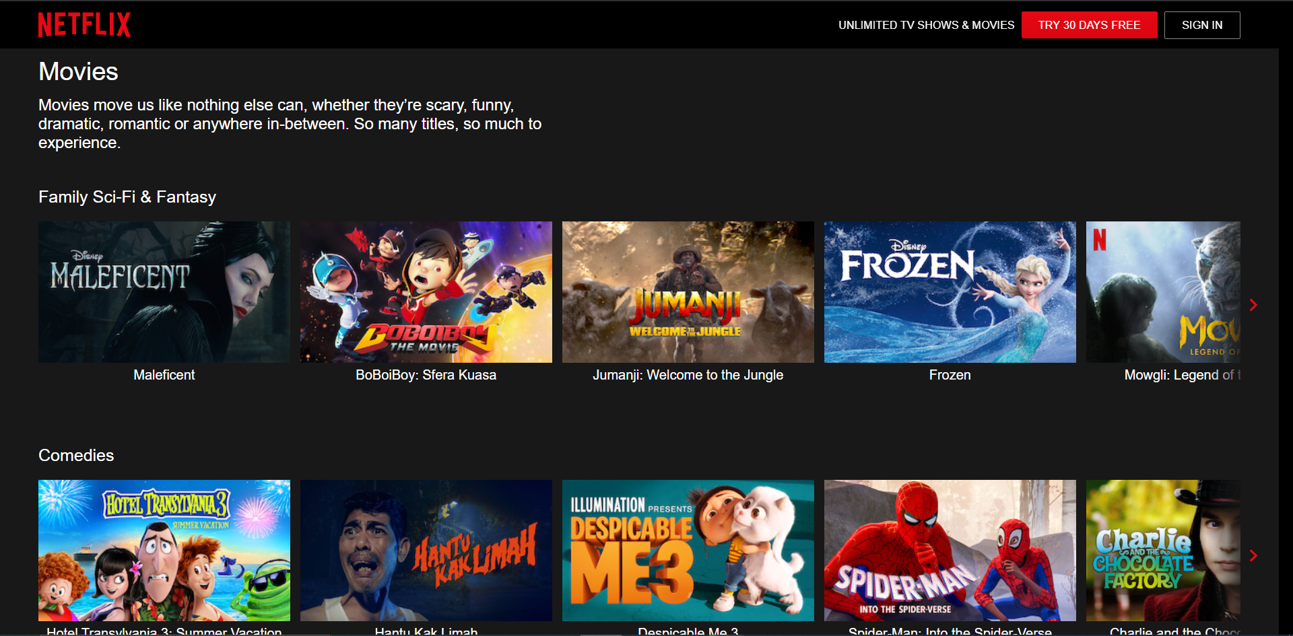

**Figure 2.1 Netflix Movies Categories** (Netflix, n.d.)

In **Figure 2.1**, it shows how Netflix categorize their movies into several genre and placing most watched movies as their thumbnails.

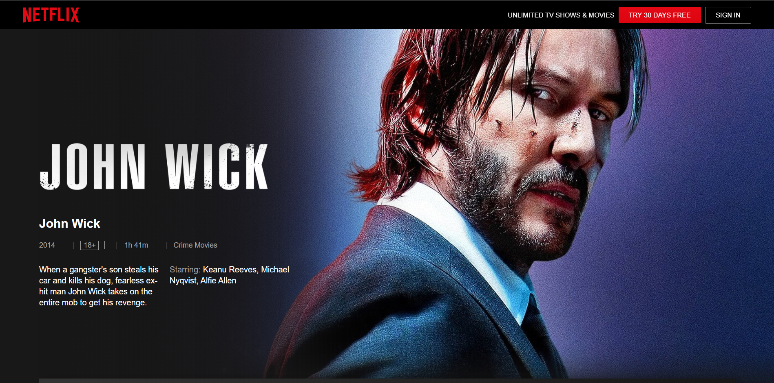

**Figure 2.2 Movie Details** (Netflix, n.d.)

In **Figure 2.2**, it is the movie details page. It consist of the movie cover, title, year published, age restriction, duration of movie, genre of movie, plot and starring.

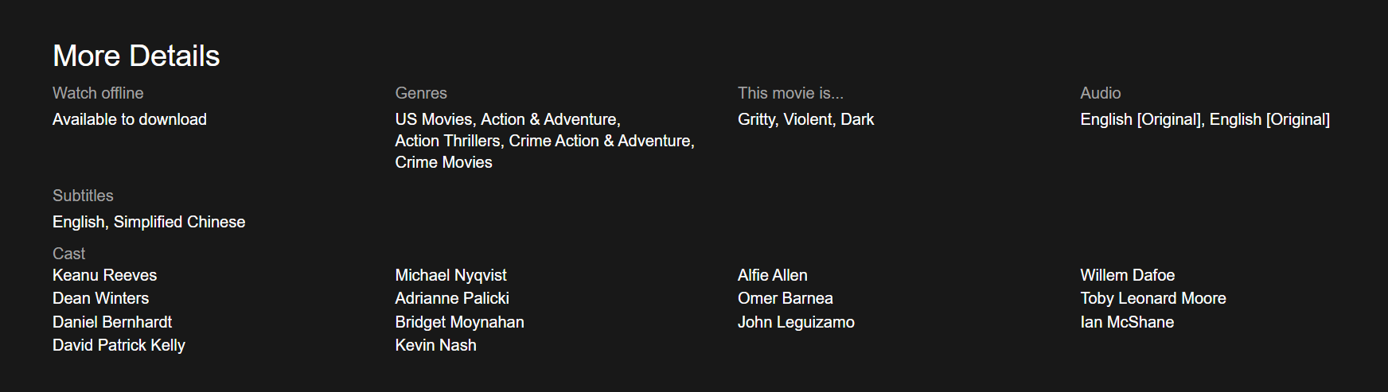

**Figure 2.3 More Movie Details** (Netflix, n.d.)

If the user scroll down, they will see more details about the movies such as link to download the movie to watch offline, genres, audio, subtitles available and cast.

### **Amazon Prime Video**

Amazon Prime Video has always been a main competitors to Netflix due to having high subscribers count and offering much cheaper subscription plans as well as student subscription plans for their users (Moskowitz, 2019). To sign up for Amazon Prime Video, the users can use their Amazon account or create one easily.

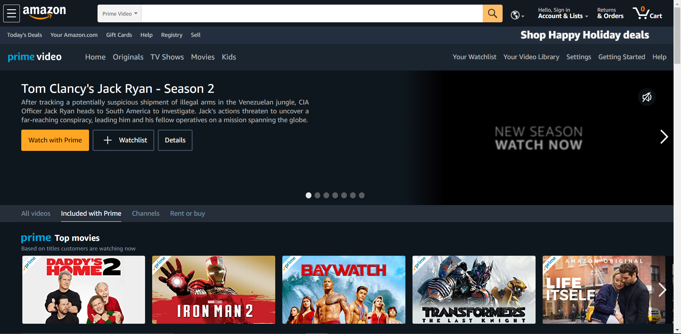

**Figure 2.4 Amazon Prime Video** (Amazon, n.d.)

In **Figure 2.4**, as you can see Amazon Prime Video is offering much better website layout then Netflix. Amazon Prime Video enable their users to search for a movie, offering daily promotions as well as different genres of movies.

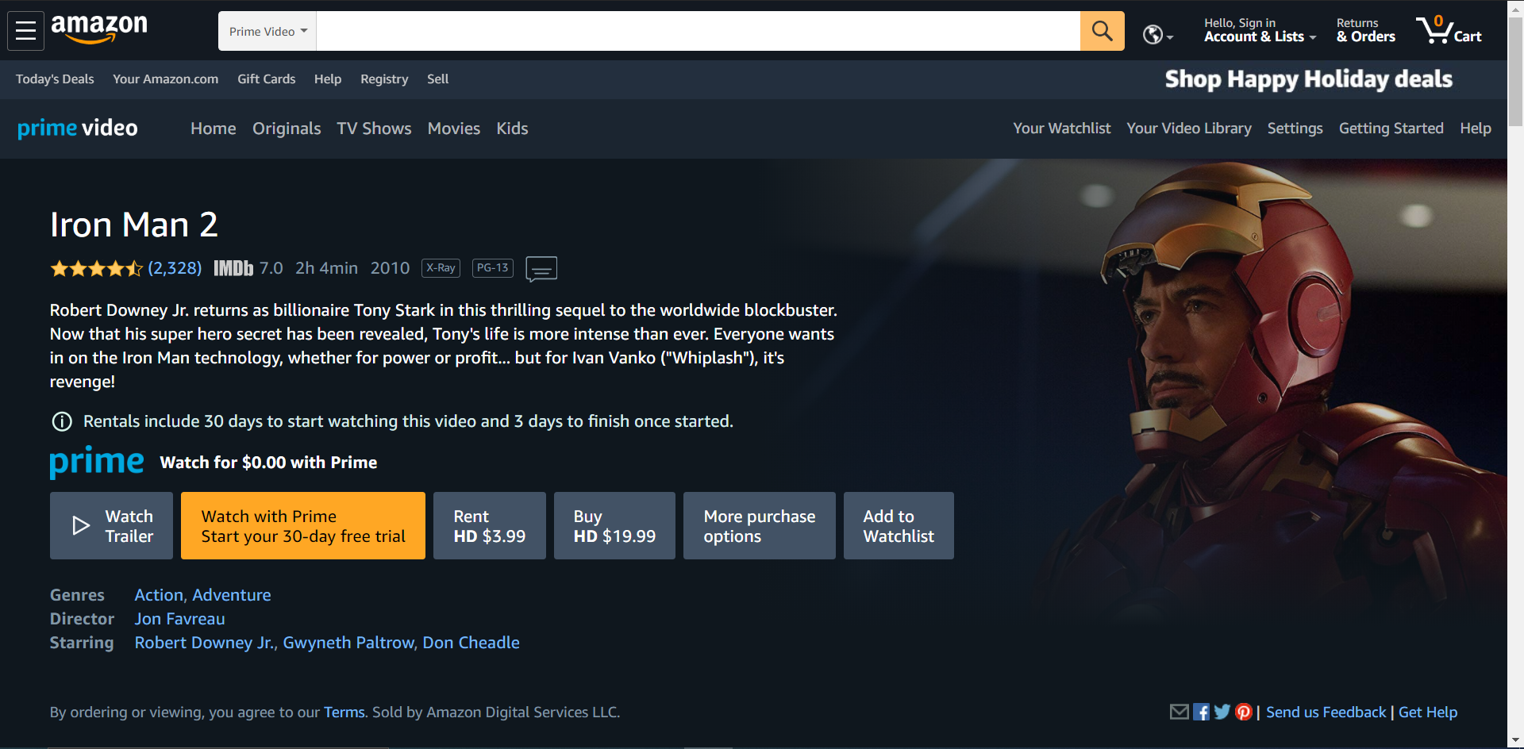

**Figure 2.5 Movie Details** (Amazon, n.d.)

In **Figure 2.5**, Amazon Prime Video shows their movie’s rating rated by users and IMDb as well as movie cover, movie duration, publish year, age restriction, plot, pricing, genres, director and starring.

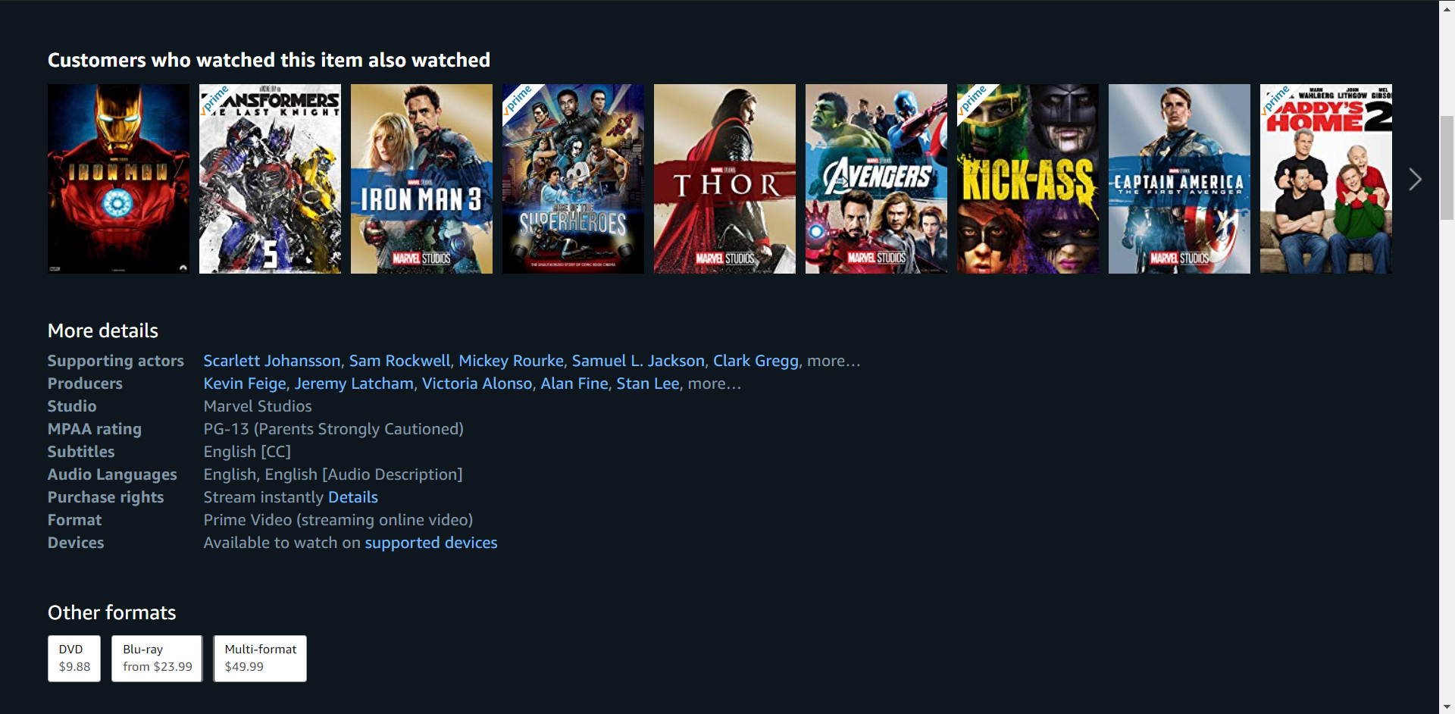

**Figure 2.6 More Movie Details** (Amazon, n.d.)

If the users scroll down to look for more information about the movie, they will see the page as **Figure 2.6** giving them more information about the movies and movie formats that they want to ship to their home address.

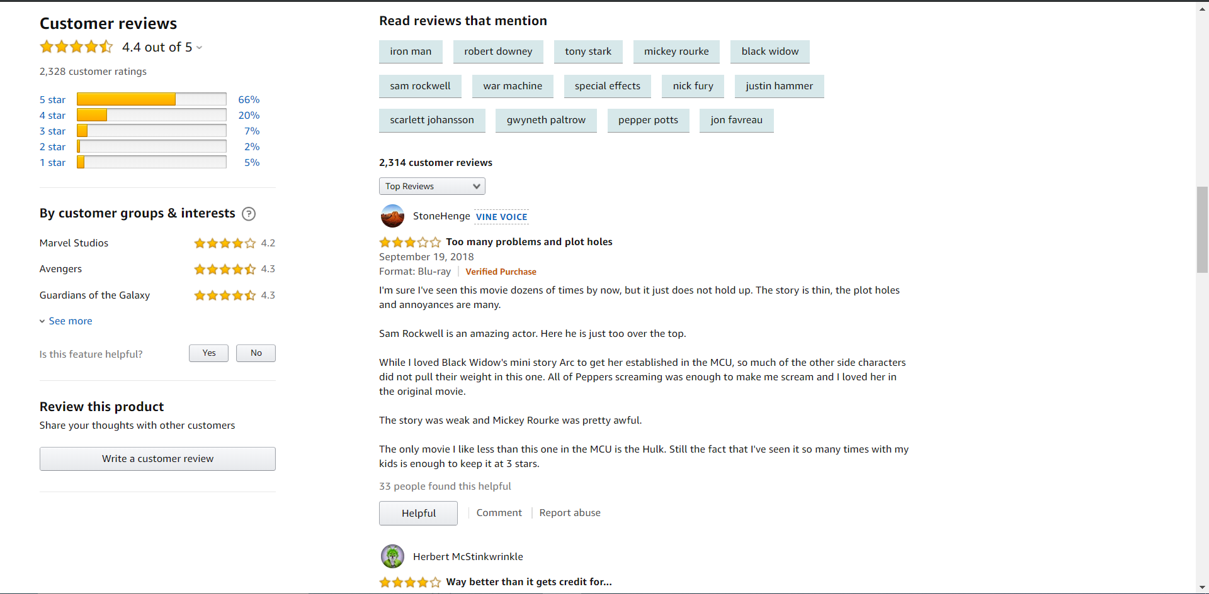

**Figure 2.7 Movie Feedback** (Amazon, n.d.)

In **Figure 2.7**, users are able to post the feedback about the movies and rate the movie as well.

### **Google Play Movies**

Google Play Movies has been doing their movie renting service for quite a long time but it didn’t get more popular as Amazon Prime or Netflix due to Google Play Movies do not offer any monthly subscription plans. To gain access into Google Play Movies, the users only need their Google Play account if they have one or create one using their Gmail.

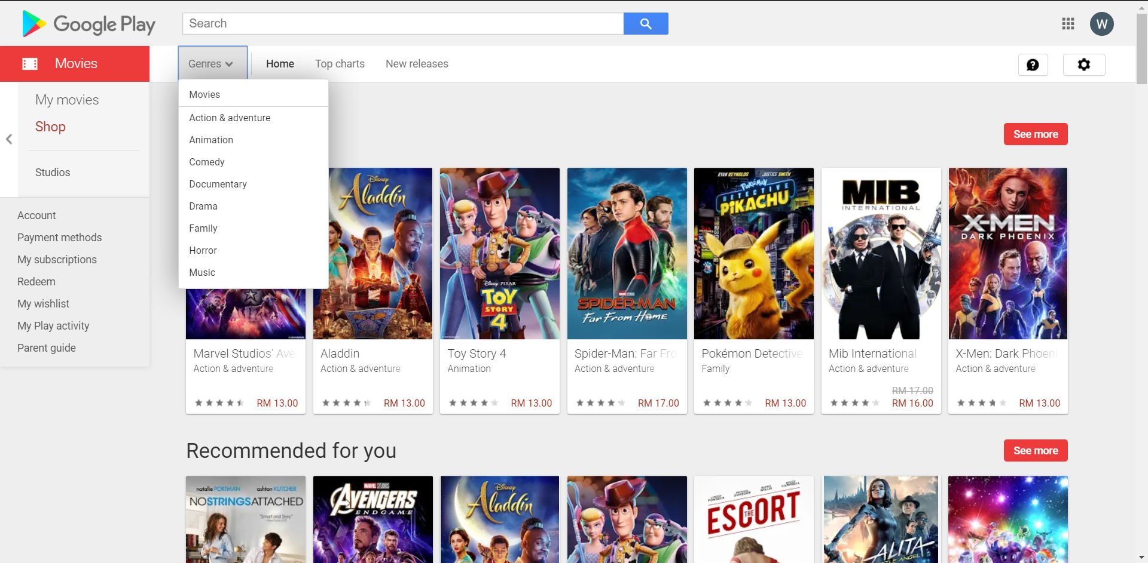

**Figure 2.8 Google Play Movie** (Google Play, n.d.)

Google Play Movies enable their users to search for the movie they want and also offer their users a list of genre to find their movie as well as a renting price shown on every movie in the page.

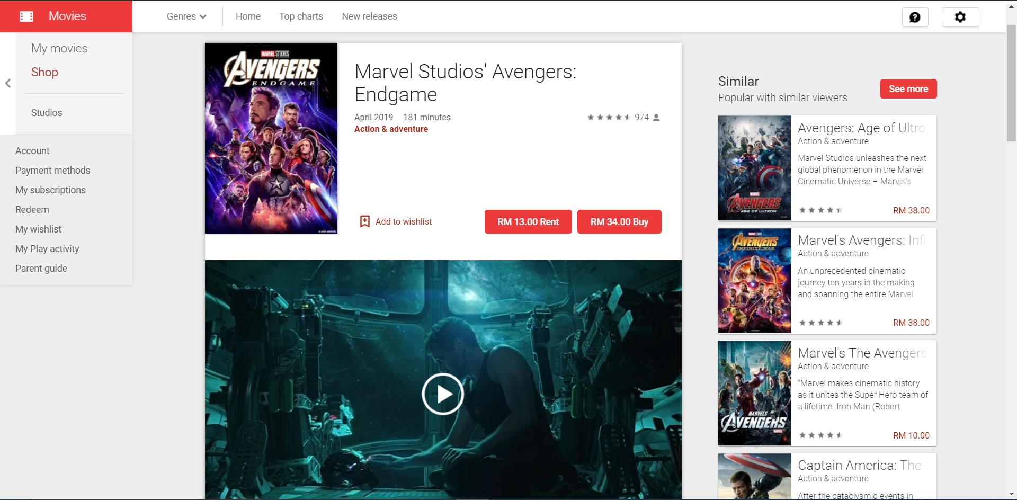

**Figure 2.9 Movie Details** (Google Play, n.d.)

Google Play Movies offered a slightly different design than others competitor, Google Play Movies do not have a movie cover and do not send out physical copies of the movies instead Google Play Movies put up the movie trailer and rent or sell a digital copy to their users for unlimited access. Other than that, Google Play Movies has every details of the movies on the page such as publish date, duration of movie, genre, feedback, cast & credits and also offer similar movies related to the current movie that user is watching.

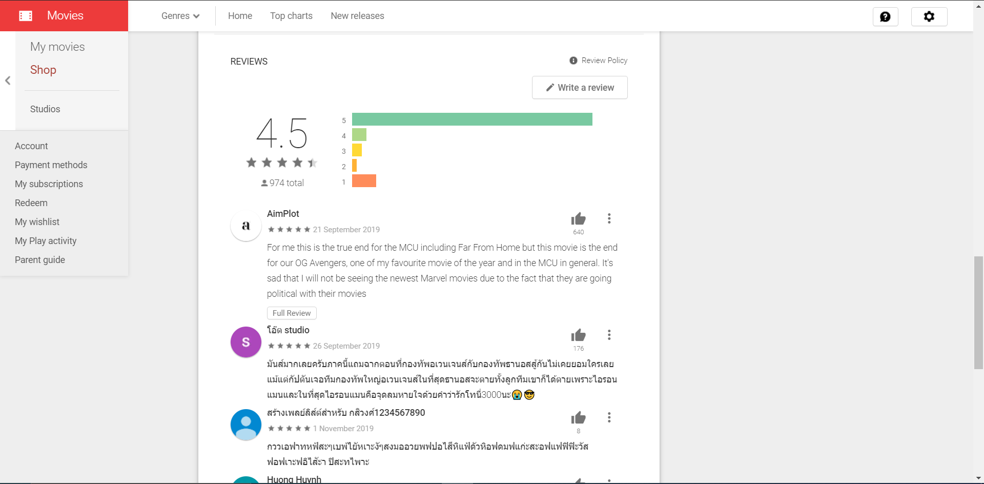

**Figure 2.10 Feedback** (Google Play, n.d.)

Users of Google Play Movies are able to gives their feedback below the movies as shown in **Figure 2.10**.

# Conclusion

Several researches have been conducted on literature reviews, I’ve improved on the topics regard to the key phrases and the 3 similar systems researched is able to help me to design and develop Movie Rental Website in this assessment.

# Reference

Amazon (n.d.) Prime Video, [online] Available at: https://www.primevideo.com/ref=atv_nb_logo (Accessed 13 October 2019).

Business Jargons (n.d.) Online Marketing, [online] Available at: https://businessjargons.com/online-marketing.html (Accessed 2 November 2019).

Discovery Design (n.d.) 5 Reasons Why Ecommerce Is So Important For Your Business, [online] Available at: https://www.discoverydesign.co.uk/blog/post/5-reasons-why-ecommerce-is-so-important-for-your-business/ (Accessed 2 November 2019).

Edkent Media (2018) TOP 15 ADVANTAGES OF INTERNET MARKETING FOR YOUR BUSINESS, [online] Available at: https://edkentmedia.com/top-15-advantages-internet-marketing-business/ (Accessed 2 November 2019).

Google Play (n.d.) Google Play Movies, [online] Available at: https://play.google.com/store (Accessed 2 November 2019).

Ho, K. (2015) How does renting work in Google Play Movies?, [online] Available at: https://www.quora.com/How-does-renting-work-in-Google-Play-Movies (Accessed 2 November 2019).

LL Brothers Entertainment Geeks (n.d.) Benefits of Watching Movies Online, [online] Available at: https://www.leclercbrothers.com/benefits-watching-movies-online/ (Accessed 2 November 2019).

Miline Library (n.d.) What Is Genre and How Is It Determined?, [online] Available at: https://milnepublishing.geneseo.edu/exploring-movie-construction-and-production/chapter/2-what-is-genre-and-how-is-it-determined/ (Accessed 2 November 2019).

Moskowitz, D. (2019) Who Are Netflix’s Main Competitors?, [online] Available at: https://www.investopedia.com/articles/markets/051215/who-are-netflixs-main-competitors-nflx.asp (Accessed 3 November 2019).

Netflix (n.d.) https://www.netflix.com/my/, [online] Available at: https://www.netflix.com/my/ (Accessed 13 October 2019a).

Netflix (n.d.) Netflix, [online] Available at: https://www.netflix.com/my/ (Accessed 3 November 2019b).

techopedia (n.d.) Online Marketing, [online] Available at: https://www.techopedia.com/definition/26363/online-marketing (Accessed 2 November 2019).

# Appendix B – Gantt Chart

